Ch 11 Practice
B Parse the following verbs:
 |  | Lexical form | 1st, 2nd, 3rd Person singular/plural | singular/plural | Aorist Active /Middle /Passive Indicative | English equivalent
1 |  | πέμπω | 2nd | plural | active | y’all sent
2 |  | πράσσω | 1st | plural | active | we did
3 |  | διώκω | 1st | singular | active | I persecuted
4 |  | πιστευω | 2rd | plural | active | y’all believed
5 |  | προσκυνέω | 3rd | singular | active | he/she/it worshiped
6 | 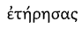 | τηρέω | 2nd | singular | active | you obeyed
7 | 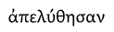 | ἀπολύω | 3rd | plural | passive | they set themselves free
8 |  | προσεύχομαι | 3rd | singular | middle | he/she/it prayed for themselves
9 | 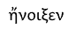 | ἀνοίγω | 3rd | singular | active | he/she/it opened
10 | 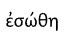why is the zeta dropped? | σῴζω | 3rd | singular | passive | he/she/it saved themselves
From chapter 4 notes: In the middle voice the subject both performs and is affected by the action. How is this reflected in the book answers 7,8 and 10.?
C Translate the following:
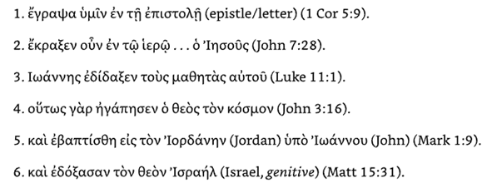 |  |  |  | 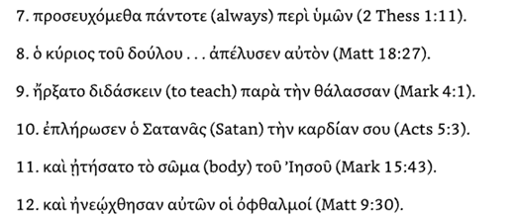
1 | εγραψα  1st sing active  I wrote | υμιν  plural dative  to you | εν  in, on at | τη  singular dative  the |  | επιστολη  singular dative  the letter
ans | I wrote to you in the letter
2 | εκραζεv  3rd sing active  he,she,it cried out | ουν  so, then, therefor | εν  in |  | τω  dative, singular | Ιερω...  dative  the temple | ο Ιησους  nominative sing
ans | so Jesus cried out in the temple
3 | Ιωαννης  Nominative sing  John | εδιδαζεν  3rd sing active  taught | Τους  plural accusative |  | μαθητας  πλθραλ accusative | αυτου  singular genitive
ans | John taught his disciples
4 | ουτως  in this manner | γαρ  because, for | ηγαπησεν  3rd sing indicative  he/she/it/loved |  | Ο θεος  Nom | τον  accusative sing | κοσμον  accusative sing
ans | because in this manner God loved the world
5 | και  and | εβαπtισθη  3rd sing passive  he/she/it baptized | εις  to,into (accusative case, but often overlaps with εν in meaning) |  | τον  sing masc accusative | Ιορδανην  Jordan
 | ὑπο  by | Ιωαννου  genitive  John
ans | and he was baptized in the Jordan by John
6 | και | εδοζασαν  3rd plural middle  he/she/it was praising | τον  Sing masc accusative |  | θεοω  God | Ισραηλ  genitive  of Israel
ans | and they praised the God of Israel
7 | προσευχομεθα  1st person plural middle indicative of  προσεύχομαι | παντοτε  always | περι  for |  | υμων  2nd genitive plural | work on 7
ans | we are praying always for you
8 | ο κυριος  nom sing masc | του  sing gen | δουλου...  slave |  | απελυσεν  3rd sing active indicative of λυω  he/she/it destroyed | αυτον  3rd sing acc  them
ans | the lord of the slave released them
9 | ηρζατο  3rd sing middle of αρχω  transcription error ζ inσtead of ξ  he/she/it began | διδασκειν  to teach | παρα  beside |  | Την Θαλασσαν  the lake
ans | he began to teach beside the lake
10 | επληρωσεν  3rd singular aorist active indicative of  πληροω  The transition from omicron (ο) in πληρόω to omega (ω) in ἐπλήρωσεν is due to a standard morphological rule for contract verbs.  In Greek, when a verb stem ends in a short vowel (like the -ο in πληρο-), that vowel must lengthen before certain tense markers, such as the -σ- used in the future and aorist tenses.  he/she/it filled, fulfilled, completed | Ο Σατανας  Satan | Την καρδιαν  singular accusative |  | σου  2nd singular genitive
ans | the Satan filled/fulfilled/completed your heart
11 | και  and | ητησατο  3rd singular aorist middle indicative of αιτεω  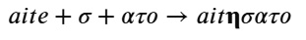  vowel stem lengthens when followed by a consonant  he/she/it asked | το σωμα  singular nominative or accusative  the body |  | του Ιησουυ  of Jesus
ans | and he asked (for himself) the body of Jesus
12 | και  and/but | ηνεωχθησαν  3rd plural aorist passive indicative of ἀνοίγω | αυτων  3rd sing gen  of them |  | οι οφθαλμοι  plural nom  the eyes
ans | and the eyes of them were opened.

Summary Table
Stage | Form | Change
Lexical | ἀνοίγω | Base dictionary form
Augment 1 | ἠνα-οίγω | Prefix initial vowel lengthens
Augment 2 | ἠνε-οίγω | Epsilon augment added after prefix
 | ἠνε-ῴγω | Root vowel (οι) lengthens to ῳ  The rule governing the change from οι to ῳ is a specific type of Temporal Augment.  When a verb starts with a vowel or a diphthong, the "augment" is not a prefixed epsilon (ε-), but rather the lengthening of that initial vowel.
Passive Marker  to make χθ pronounceable | ἠνεῳχ-θη- | Stem gamma becomes chi before theta
Ending | ἠνεῴχθησαν | 3rd person plural suffix added
D. Translate the following:
1 | He prayed in the synagogue. | αὐτος ἐπροσεύξεν ἐν τήν συναγωγήν
2 | The teacher was gathering the disciples and taught them. | - 3rd singular imperfect(was gathering) active indicative of συναγω = συνηγεν (Augment: In compound verbs like συνάγω (prefix συν- + ἄγω), the augment (ε) is inserted between the preposition and the verb stem.  )  3rd singular aorist active indicative of διδασκω =ἐδιδαξεν  ὁ διδασκαλος συνηγεν τόυς μαθητας¹ και ἐδιδαξεν αὐτους
3 | The angel glorified God before his throne. | 3rd person singular aorist active indicative of δοξάζω =  ἐδοξασεν  ὁ αγγελος ἐδοξασεν Θεον ἐνωπιον αὐτου θρονου
4 | We did not believe the demon. | 1st person plural aorist active indicative of πισευω =  ἐπισευσαμεν  ἡμεις οὐκ επισtευμεν το δαιμονιον
5 | The joy of the Lord guarded us in the boat. | 3rd person singular aorist indicative of τηρεω = ἐτηρεσεν  ἠ χαρα του κυριου ἐτηρεσεν ἠμας ἐν τω πλοιω
1 The "Masculine A-Declension"
Most first-declension nouns end in -α or -η and are feminine. However, nouns that denote male roles or occupations often use the first-declension endings but retain their masculine identity.
Common examples include:
- ὁ μαθητής (the student)
- ὁ προφήτης (the prophet)
- ὁ στρατιώτης (the soldier)
- ὁ νεανίας (the young man)

